Exp: 1
Implement and demonstrate the FIND-S algorithm for finding the most specific hypothesis
Aim
To implement and demonstrate the FIND-S algorithm for finding the most specific hypothesis from a given set of training data samples.

Procedure
- Create a CSV file containing the training dataset.
- Import the required Python libraries.
- Read the dataset from the CSV file.
- Initialize the hypothesis using the first positive training example.
- Compare the hypothesis with each positive training example.
- If an attribute value differs, replace it with "?".
- Ignore all negative training examples.
- Repeat the process until all training samples are processed.
- Display the final most specific hypothesis.

Python Code
# FIND-S Algorithm
# Training dataset
data = [
['Sunny', 'Warm', 'Normal', 'Strong', 'Warm', 'Same', 'Yes'],
['Sunny', 'Warm', 'High', 'Strong', 'Warm', 'Same', 'Yes'],
['Rainy', 'Cold', 'High', 'Strong', 'Warm', 'Change', 'No'],
['Sunny', 'Warm', 'High', 'Strong', 'Cool', 'Change', 'Yes']
]
# Initialize hypothesis with the first positive example
hypothesis = None
for example in data:
if example[-1] == 'Yes':
hypothesis = example[:-1]
break
# Apply FIND-S algorithm
for example in data:
if example[-1] == 'Yes':
for i in range(len(hypothesis)):
if hypothesis[i] != example[i]:
hypothesis[i] = '?'
# Display the final hypothesis
print("Most Specific Hypothesis:")
print(hypothesis)

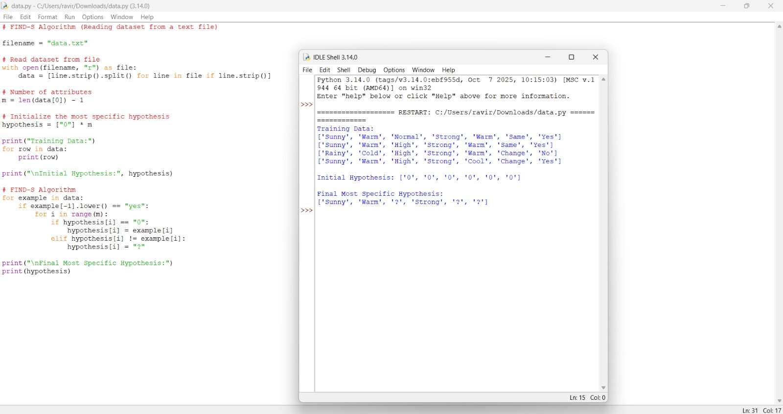
Output:
Result:
The FIND-S algorithm was successfully implemented using Python. The algorithm processed the given training data and generated the most specific hypothesis that is consistent with all the positive training examples.

